

**Artificial Intelligence**

**Assignment 01**

**Name :** Hussain Ali

**Reg No. :** FA21-BCS-066

**Section :** BCS-7A

**Instructor :** Mam Seema Islam

**Lab Task 02**

**BFS Code Screen Shots:**

**Code:**

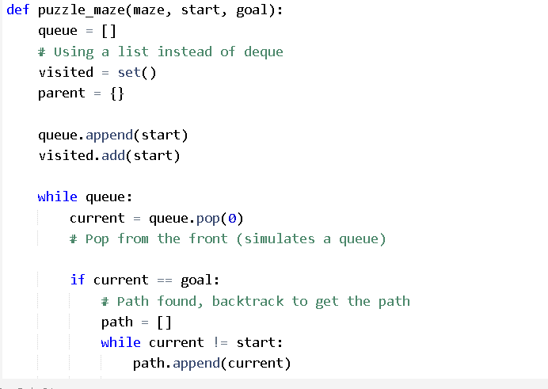

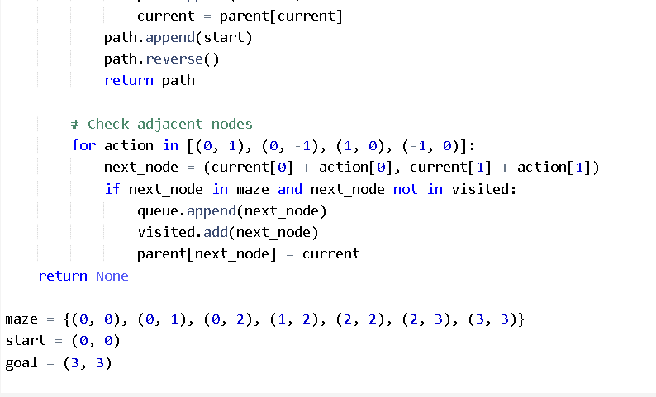

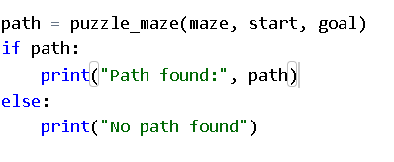

**Output:**

